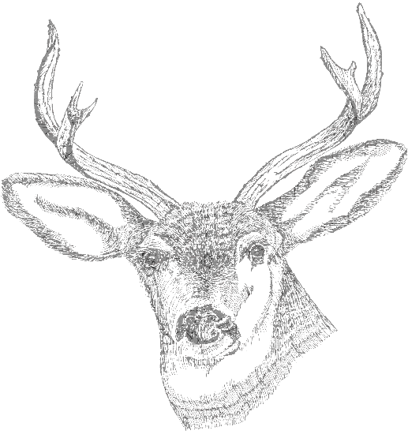

Green Valley Sportsman’s Club

**101 Fishpot Rd. Monaca PA 15061**

President – Randy Wilson Vice President – Jim Price

Secretary – Cal Roberts Treasurer – Stan Stickles

Membership Application

Name: _______________________________ Date: ___/___/___

Address: ______________________________________________________________________

Phone: HP: ____________________________ CP: ___________________________________

Email Address: (necessary for club communications)__________________________________

Personal Identifying Information

Hair Color: ________ Eye Color: ________ Height: ________ft. ________in.

Weight: ________ Date of Birth: ________ US Citizen: Yes________ No _______

Are you a member of the NRA? Yes_______ No _______

Are you currently a member of other sportsman’s clubs? Yes ________ No _______

Other Organizations you belong to: _________________________________________________

______________________________________________________________________________

Place of Employment: ____________________________________________________________

Reason for Requesting Membership in this club: ______________________________________

______________________________________________________________________________

Your Sponsor’s Signature: ____________________________Printed Name: ________________

Your Signature: ____________________________________

Membership Application Page 2

______________________________________________________________________________

As of 2016 all Memberships are Family Memberships

New Member - $100 First Year Social Member

Re Newal Membership - $50 for Voting Member $100 for Social Members

Youth Membership: (12-18) $5 Youth Members are NOT permitted to have access code

TIER MEMBERSHIP

Voting or Social

The Dues Paid By 11-30-2016 will remain the Same and be considered a Voting Member! HOWEVER the “work hours” will no longer be in effect. The Point System will take effect as follows:

Club Meetings…………………………………………………...1pt

Work Parties (scheduled or unscheduled)…………………….3pt

Special Events (unless otherwise posted on website)............2pt

**A Total of 16 Points are needed** throughout the year to be qualified as a **VOTING** Member!

If Points are NOT met throughout the year you will become a Social Member **without** voting rights! **Voting Members will be issued a specific colored card that Must Be Present at Every meeting you attend to ensure your right to vote!**

**Family membership: Defined as spouse, their children (spouses children), grandchildren, parents (in-laws), Grandparents. No other relatives or friends are included (brothers, sisters, uncles, aunts, cousins).**

**General Club Rules ____________________________________________________________________**

The club and its ranges, facilities and grounds are for Members Only! Guests Are NOT permitted.

**Sign In Log** - The sign in Log Book must be signed by the member each tie he/she uses the club. All family members must sign in as well, whether using the ranges or not. This is an important club rule which is for the club's insurance Policy requirements. **Failure to do so Can Result in TERMINATION of Membership**

**Range Fees** - When using any of the Ranges $1 per each use and to be paid by everyone using the ranges. Pay fees when signing the Log Book.

**Monthly Club Meetings**: 2nd Thursday of Each Month (Except July) at 7pm. Your attendance at these meetings are encouraged. (see points structure above)

**Work Day**: The Saturday following the Monthly Meetings. Attendance is encouraged (see points structure above).

**Securitas:** Shippingport Nuclear Plant security firm has a contractual use of the outdoor range facilities that does take precedence during their scheduled times of the week. (see website or club post board for closure schedule). They are generally very cooperative with our club members about use of the range when they are there, but, there may be tines when they may ask club members to not be there so PLEASE be understanding. They are Training for the defense of the nuclear plant against hostile attack.

GVSC Rules of Etiquette & Sportsman - like Conduct

1. Keep the Club grounds neat and clean. Police up the brass and other refuse you create when using the facility
2. Report any vandalism or other problems you recognize to Club Officers
3. Obey the "Members Only" rule as described earlier
4. Pay your range fees when you use the indoor and outdoor ranges. The annual dues you pay do not cover all the costs of operating out club
5. Always remember that you Must sign in & Out of the Sign In Logbook each time you come to the club, regardless the reason.
6. Help out When you can! Participate in the "Work Day" Saturdays. It's our club, so when you have time your participation is Appreciated!
7. Help the club Financially. Participating in the Club Raffles (buying or selling tickets) are key to helping to keep the club financially stable. So PLEASE Participate!

I have read all the information contained in this application and I have filled out the membership application honestly and truthfully.

Applicant's Initials: ____________

The Green Valley Sportsman's Club Thanks You for your membership support. Any Help and suggestions you can provide are greatly appreciated.